** Operating Instructions for CurlTime 2015 version 6.3.01**

With thinking time. For stone colours  **red**  /  **yellow** .

**Thinking Time**: The game clock only runs during the thinking time.

If a **stone is in motion** there is **no clock running**.

1. **Timekeeping**

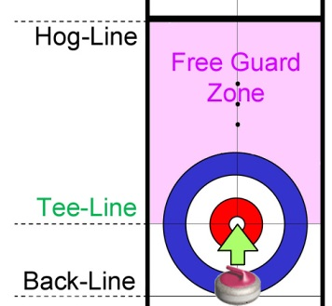**The clock does not run for the 1st stone of an end.** Only start the clock if the 1st player does not begin delivering the stone while the 10-seconds timer runs after the end of a break.

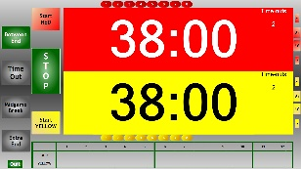**Timekeeping window 🡄** Screenshot:

**Start the clock** when: Display on the

* All stones have come to rest laptop
* or have crossed the Back-Line,
* all displaced stones (because of violations) has been repositioned
* **and** the playing area is cleared: relinquished to the other team.

**Key Q : start clock for top team** /  **Q stop clock when stone at Tee-Line *.**

**Z : bottom team** /  **Z**  * Hog-Line in wheelchair curling ♿

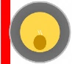**Violation of the «free guard zone rule» or the «no-tick rule»: (No-tick rule: not No clock is running when the stones are repositioned. mixed doubles, ♿)**

**Game clocks are stopped at any time an umpire intervenes.**

|  |
| --- |
|  |

1. **Breaks:**  End finished (stones measured / all stones in the house have been moved):

**Key F1 : starts 1 minute break between ends** (mixed doubles 90 seconds).

**F5 : starts 5 minutes midgame break** (at half-time).

During the break, note the remaining playing time of both teams and the score (timing-form).

At the end of a break, a **10-seconds countdown clock runs.**  **Press** key  **Q**  or  **Z**  if:

* Team starts **before the end of the break** (clock **does not start**).
* **Normal case**: Team starts **while** the 10-seconds timer is running (clock **does not start**).
* Team starts **after the 10-seconds timer** has **expired** (clock **starts**). But stop the clock when the stone has reached the nearer **Tee-Line**.

|  |
| --- |
|  |

1. **T****eam Time-Out** (**Clock must run** fort the team): Forming a **T** with the hands.

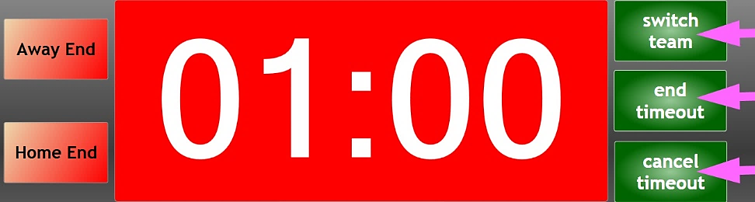**Key T TO : Time-Out** ,

then select the **playing end**

by clicking on:

* **Away End** *or* press key  **A**
* **Home End** *or* press key  **H**
* If the **timeout** was started for the **wrong playing end**: Switch to the other end by **clicking on the other end** (or press the key  **A**  respectively  **H** ).
* If the **timeout** was started for the **wrong team**: Switch to the other team by **clicking on  switch team** **🡄** .
* **Cancel a timeout started by error** by clicking on **cancel timeout** **🡄** .

**Mark the timeout with a T for the corresponding team and end on the timing-form.**

*The travel time runs first, followed by the timeout. The game clock does not run.*

If the **game restarts before the timeout expires**: Click on **end timeout** **🡄**.

**After the timeout the clock must be restarted for the playing team unless a stone is played:** **Key  Q (top team) or Z (bottom team)** .

|  |
| --- |
|  |

1. **Technical Time-Out** (forming an **X** with the arms): **Stop clock by pressing key X .**

** Operating Instructions for CurlTime 2015 version 6.3.01**

With thinking time. For stone colours  **yellow**  /  **red** .

**Thinking Time**: The game clock only runs during the thinking time.

If a **stone is in motion** there is **no clock running**.

1. **Timekeeping**

**The clock does not run for the 1st stone of an end.** Only start the clock if the 1st player does not begin delivering the stone while the 10-seconds timer runs after the end of a break.

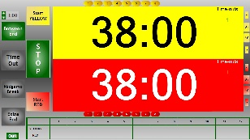**Timekeeping window 🡄** Screenshot:

**Start the clock** when: Display on the

* All stones have come to rest laptop
* or have crossed the Back-Line,
* all displaced stones (because of violations) has been repositioned
* **and** the playing area is cleared: relinquished to the other team.

**Key Q : start clock for top team** /  **Q stop clock when stone at Tee-Line *.**

**Z : bottom team** /  **Z**  * Hog-Line in wheelchair curling ♿

**Violation of the «free guard zone rule» or the «no-tick rule»: (No-tick rule: not No clock is running when the stones are repositioned. mixed doubles, ♿)**

**Game clocks are stopped at any time an umpire intervenes.**

|  |
| --- |
|  |

1. **Breaks:**  End finished (stones measured / all stones in the house have been moved):

**Key F1 : starts 1 minute break between ends** (mixed doubles 90 seconds).

**F5 : starts 5 minutes midgame break** (at half-time).

During the break, note the remaining playing time of both teams and the score (timing-form).

At the end of a break, a **10-seconds countdown clock runs.** **Press** key  **Q**  or  **Z**  if:

* Team starts **before the end of the break** (clock **does not start**).
* **Normal case**: Team starts **while** the 10-seconds timer is running (clock **does not start**).
* Team starts **after the 10-seconds timer** has **expired** (clock **starts**). But stop the clock when the stone has reached the nearer **Tee-Line**.

|  |
| --- |
|  |

1. **Team Time-Out** (**Clock must run** fort the team): Forming a **T** with the hands.

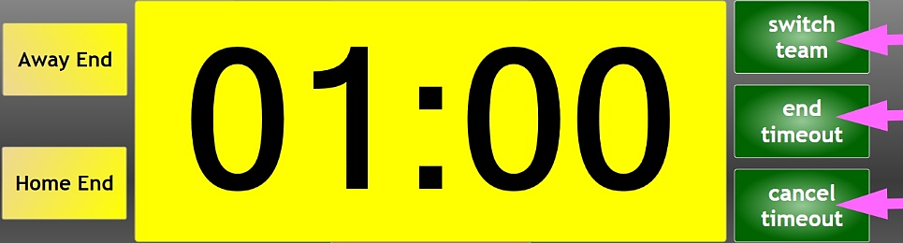**Key T TO : Time-Out** ,

then select the **playing end**

by clicking on:

* **Away End** *or* press key  **A**
* **Home End** *or* press key  **H**
* If the **timeout** was started for the **wrong playing end**: Switch to the other end by **clicking on the other end** (or press the key  **A**  respectively  **H** ).
* If the **timeout** was started for the **wrong team**: Switch to the other team by **clicking on  switch team** **🡄** .
* **Cancel a timeout started by error** by clicking on **cancel timeout** **🡄** .

**Mark the timeout with a T for the corresponding team and end on the timing-form.**

*The travel time runs first, followed by the timeout. The game clock does not run.*

If the **game restarts before the timeout expires**: Click on **end timeout** **🡄**.

**After the timeout the clock must be restarted for the playing team unless a stone is played:** **Key  Q (top team) or Z (bottom team)** .

|  |
| --- |
|  |

1. **Technical Time-Out** (forming an **X** with the arms): **Stop clock by pressing key X .**